**CMPS 350 Project Phase 1 – Report**

**Education Platform**

**(10% of the course grade)**

**The report must be submitted in Word format only**

|  |  |
| --- | --- |
| **Group Members** | Abdul Rahim Alsheikh Mahmoud (202210090)  Abdalrehman Daud (202203615)  Anas Elrahmani (202203650)  **Emails:** am2210090@student.qu.edu.qa; ad202203615@student.qu.edu.qa; ae2203650@student.qu.edu.qa; |
| **GitHub link** | Give a public link to you code (It is not acceptable to send codes by email) |

**Grades :**

**The student fills only the “Implementation Percentage”: Please specify either: *Working (completed x%)*, *Not Working (completed x%)* or *Not done*.**

|  |  |  |  |  |
| --- | --- | --- | --- | --- |
| **Criteria** | **Points** | **Implementation Percentage** | **Implementation Quality** | **Your Grade** |
| Design and implement the app Web UI and navigation using HTML, CSS and JavaScript. Including designing the App Web UI and navigation. | 50 | 100% |  |  |
| Design and implement the Web API and data access repositories to read/write the app data JSON files. | 30 | 100% |  |  |
| Application modeling (e.g. UML diagrams) to explain the data entities and the functionalities | 5 | 100% |  |  |
| Testing documentation using screen shots illustrating the testing results. | 5 | 100% |  |  |
| Team work quality. Contributions of team members - All members should collaborate and contribute equally to the project. | 5 | 100% |  |  |
| Project report – description of the implemented app, what is implemented, what is missed .. | 5 | 100% |  |  |
| **Total** | 100 |  |  |  |
| **Plagiarism, outsourcing, free riders** | -100 |  |  |  |
| **Delivery behind the deadline** | -5 |  |  |  |

**Important remark: In case of copying and/or plagiarism or not being able to explain or answer questions about the implementation, you lose the whole grade.**

**\* Criteria for grading the functionality:**

- The functionality is working: you get 70% of the assigned grade.

- The functionality is not working: you lose 40% of assigned grade.

- The functionality is not implemented: you get 0.

- The remaining grade in all cases from above **is assigned to the quality of the implementation**,

- The grades are distributed on the various use cases, when the design/implementation is partial, you get only the grades of designed/implemented use cases.

Code quality criteria, include:

- Use of meaningful identifiers for variables and functions (e.g. using JavaScript naming conventions)

- Pages are responsive

- Clean code: simple and concise code, no redundancy

- Clean implementation without unnecessary files/code

- Use of comments where necessary

- Proper code formatting and indentation.

**You lose marks** for code duplication, poor/inefficient coding practices, poor naming of identifiers, unclean/untidy submission, and unnecessary complex/poor user interface design.

**Important Remark**:

**[Grades: 100-85]:** Will be given only to **fully functional application** with **all the quality criteria cited above met** and the project has excellent **design for the various functionalities**. **The report is professional**.

**[Grades: 85-80]:** Will be given only **to functional application** **with most of all the quality criteria cited above met** and the project has good design for the various functionalities. **The report is professional**.

**[Grades: 80-75]:** 80% of the application functionalities are functional. The project respects partially the quality criteria. **The report is professional** but misses some information.

The grades are not negotiable. We expect that only a small portion (around 15%) of the class will be able to meet the criteria for the grades **[100-85]. You should work hard to and demonstrate the merits of your application to earn those grades.+**

# Description of your proposed platform

This platform supports three user types: **admin-instructor**, **instructor**, and **student**. The login page identifies the user's role based on their email address and navigates them to their respective main page.

The **admin** has access to three main pages. **Home** displays general university information. **Courses** shows the courses the admin is teaching, and allows them to assign grades to students. **Registration** includes three sections: **Under Process**, which lists pending courses that the admin can approve; **Approved**, where approved courses can be marked as completed; and **Add Course**, which allows the admin to add new courses or sections.

The **instructor** has two main pages. **Home** shows university-wide announcements. **Courses** lists the instructor’s current classes, and allows them to submit grades for students in each course.

The **student** has access to four main pages. **Home** displays both university updates and the student’s own information. **Courses** shows the courses the student is enrolled in. **Registration** includes three sections: **Register**, to view and register in pending courses; **Schedule**, to view the weekly course timetable; and **Summary**, which displays the registered courses with an option to withdraw. The **Path** page shows the student’s academic path with details such as status and grades.

Additionally, all users can access **Settings** and **Help & Support** pages for profile management and assistance.

Give an overview of how your application works

# Application Design

# Use case diagram

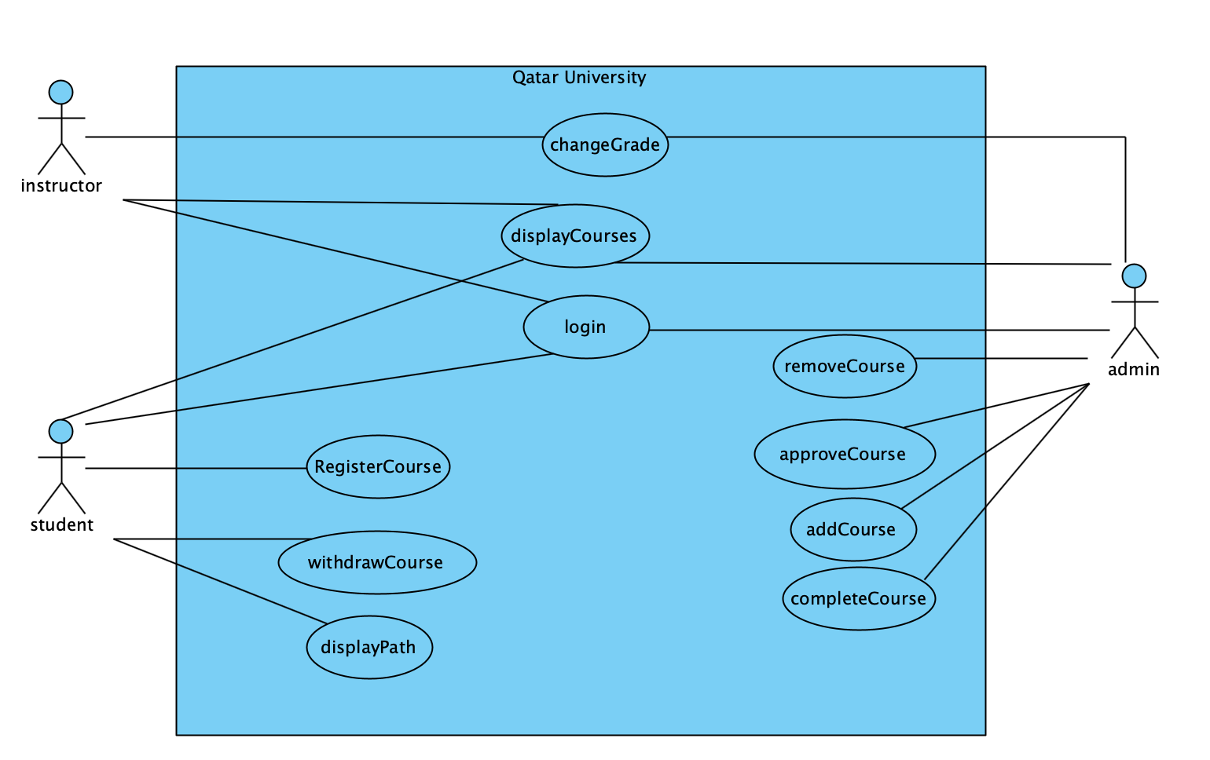

# Entities class diagram

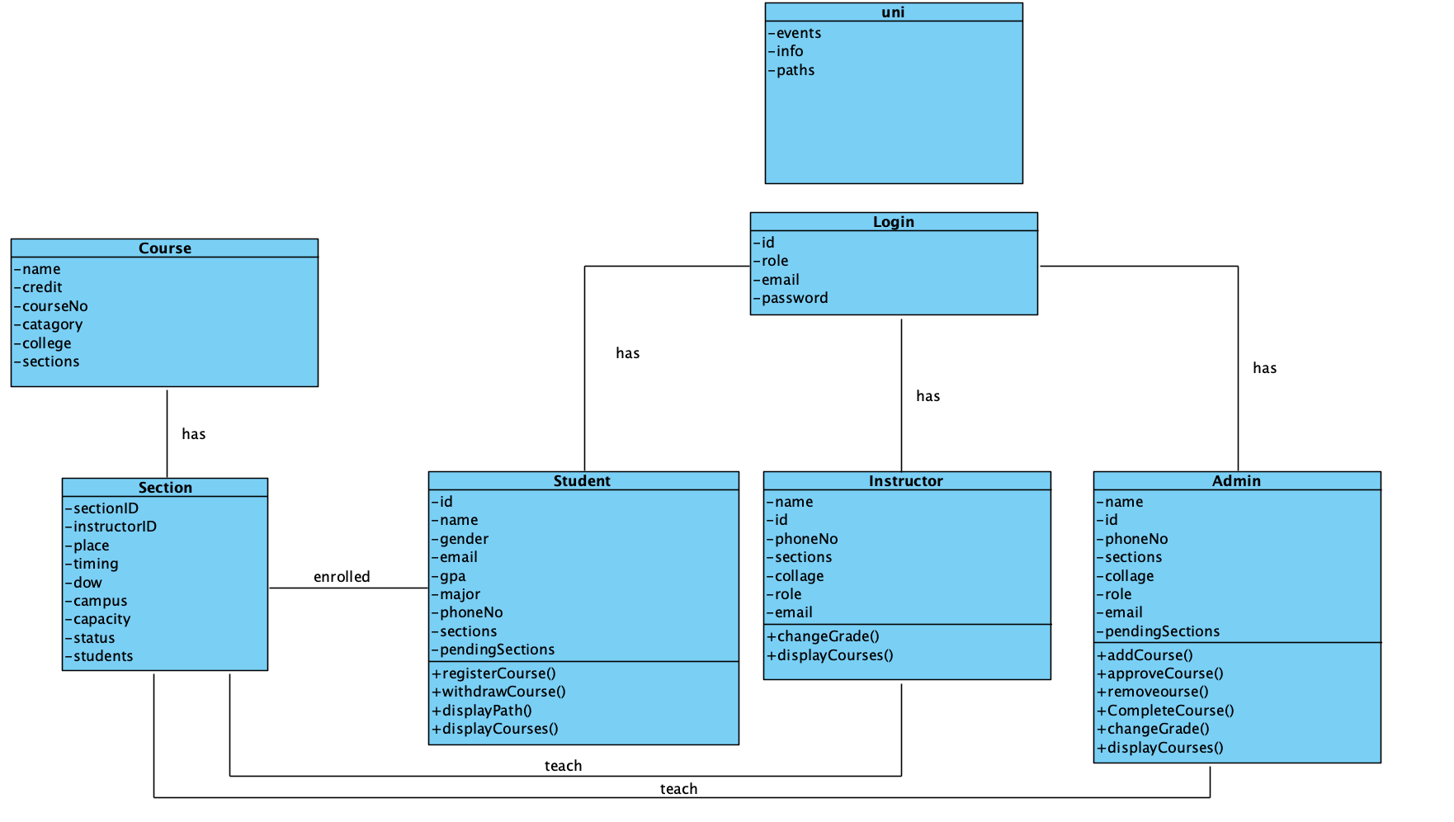

Describe your data as a class diagram or Entity Association diagram

# Web API class

**Admin Methods**

|  |  |
| --- | --- |
| **Method** | **Description** |
| getAdmins() | Get all admins |
| getAdmin(id) | Get a specific admin by ID |
| updateAdmin(admin) | Update an existing admin |
| saveAdmins(admins) | Save the full admin list to JSON |

**Course Methods**

|  |  |
| --- | --- |
| **Method** | **Description** |
| getCourses(status, campus) | Get all courses; can be filtered by status or campus |
| getCourse(courseNo) | Get a specific course by course number |
| addCourse(course) | Add a new course |
| updateCourse(course) | Update an existing course |
| saveCourses(courses) | Save the full courses list to JSON |

**Student Methods**

|  |  |
| --- | --- |
| **Method** | **Description** |
| getStudents() | Get all students |
| getStudent(id) | Get a specific student by ID |
| updateStudent(student) | Update an existing student |
| saveStudents(students) | Save the full student list to JSON |

**Instructor Methods**

|  |  |
| --- | --- |
| **Method** | **Description** |
| getInstructors() | Get all instructors |
| getInstructor(id) | Get a specific instructor by ID |
| updateinstructor(instructor) | Update an existing instructor |
| saveInstructors(instructors) | Save the full instructor list to JSON |

**Login / User Methods**

|  |  |
| --- | --- |
| Method | Description |
| getUsers() | Get all login records |
| getUser(email, pass) | Get user object by email and password |
| updateUser(user) | Update a user’s login info |
| savelogins(logins) | Save login data to JSON |

**University Info Methods**

|  |  |
| --- | --- |
| **Method** | **Description** |
| getUni() | Get university general information (calendar, etc.) |
| getPaths() | Get all learning paths from uni.json |
| getPath(name) | Get a specific learning path by name |
| saveUni(unis) | Save university data to JSON |

# Implementation

# Implemented use-cases

**Use Case 1: Login**

* login() path : Admin\js\index.js

**Use Case 2: Search and display available courses**

* displayRegisterCourses(courses) path: Student\js\index.js

**Use Case 3: Register in a course**

* displayRegisterCourses(courses) path: Student\js\index.js
* registerCourse(courseNo, sectionID)
* WithdrawCourse(courseNo, sectionIndex)
* **all under same path -> path : Student\js\index.js**

**Use Case 4: View their learning path**

* displayPath() path: Student\js\index.js

**Use Case 5: Creating / validating courses and classes**

* addCourse()
* removeCourse(courseNo, sectionID)
* approveCourse(courseNo, sectionID)
* completeCourse(courseNo, sectionID)

**all under same path -> path : Admin\js\index.js**

# Unimplemented use-cases and not functioning parts

# Testing

# Use case 1

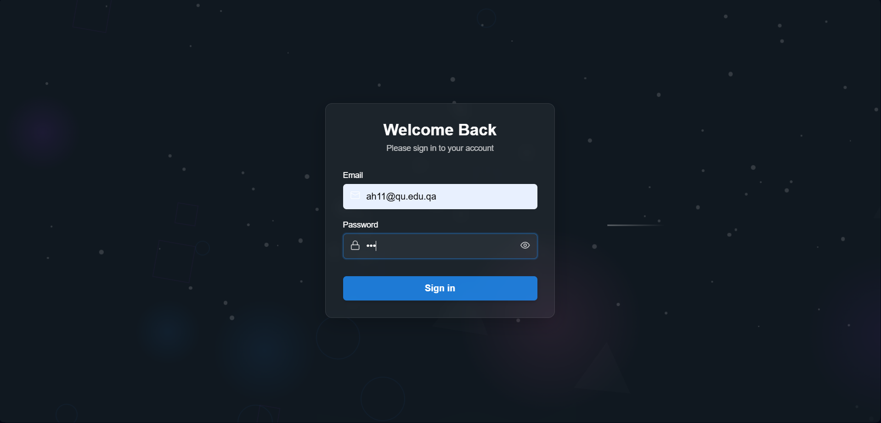 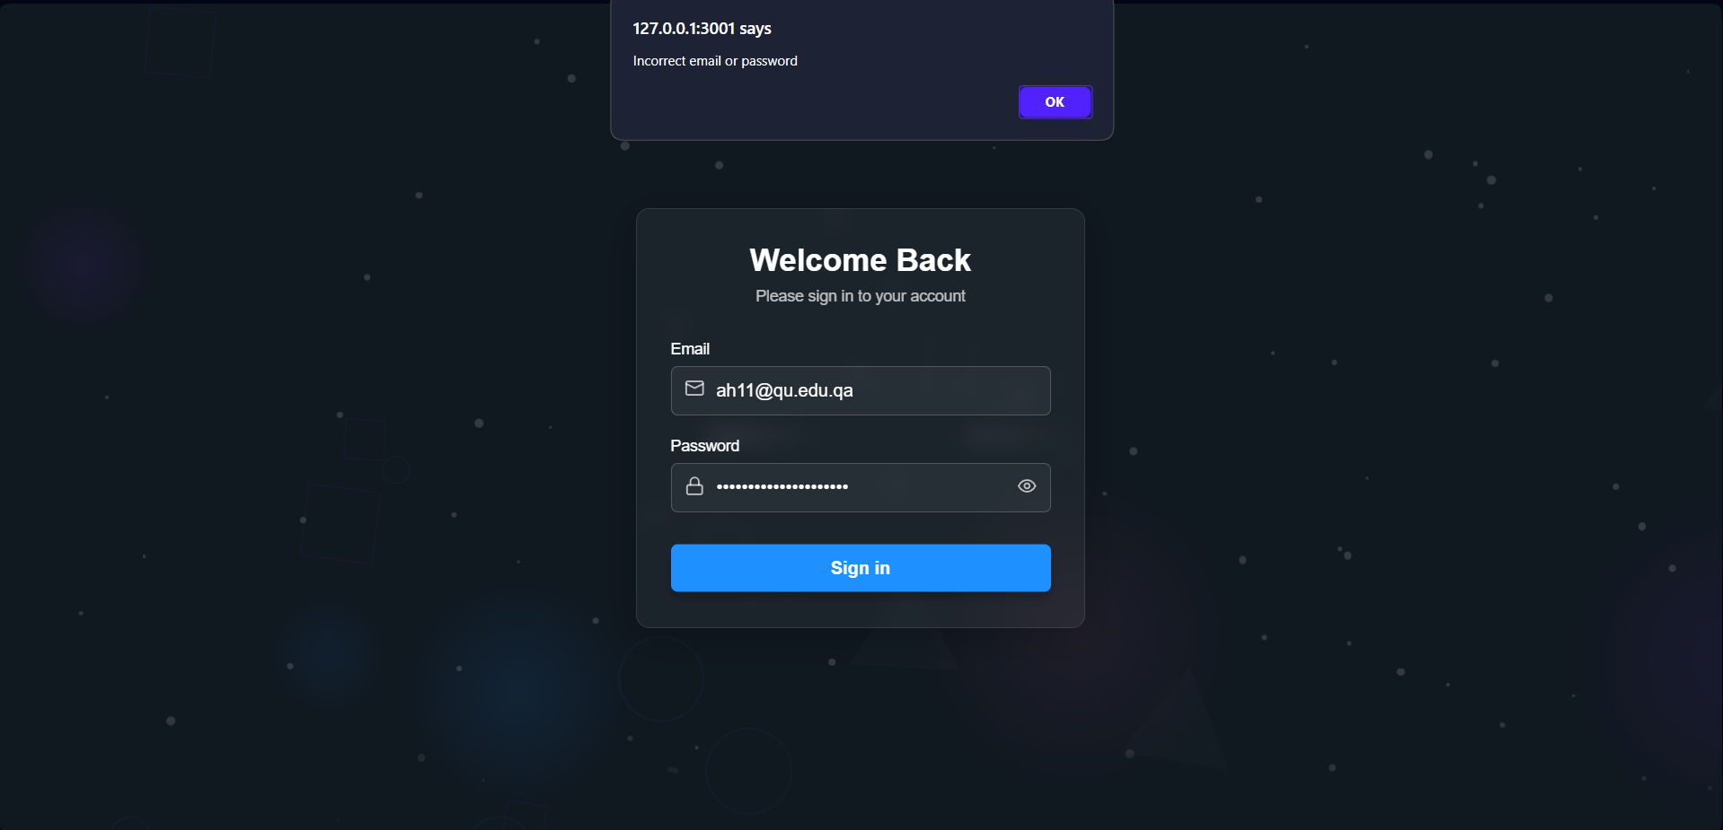

# Use case 2 and 3

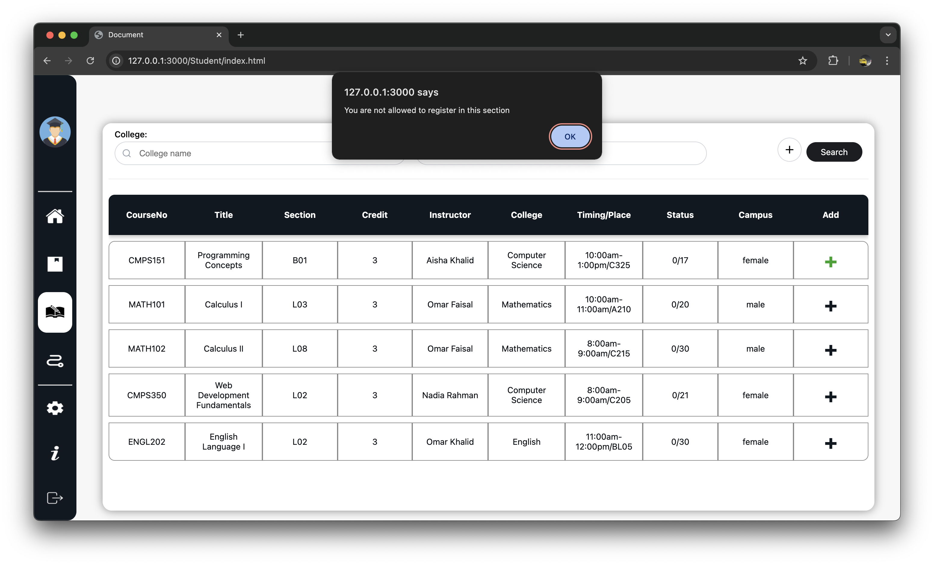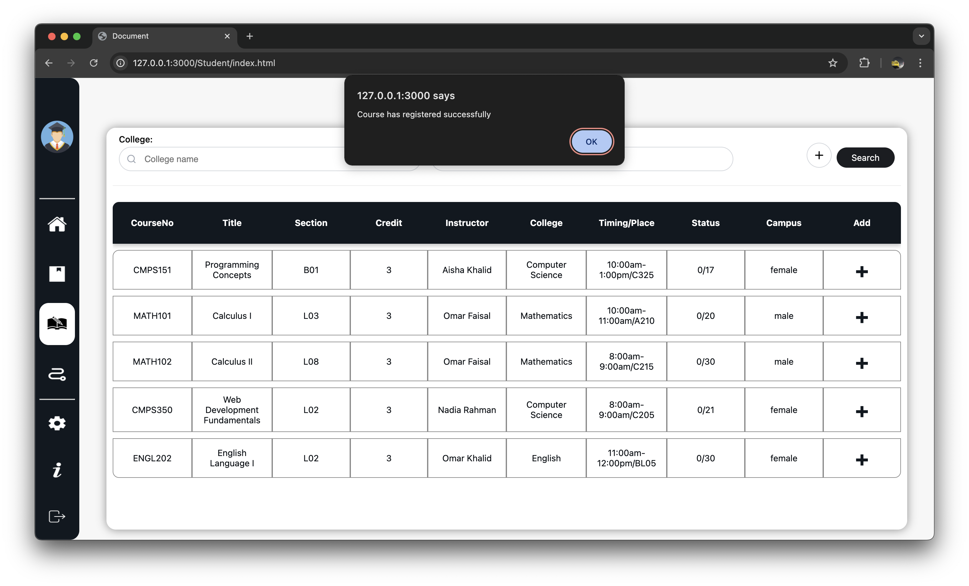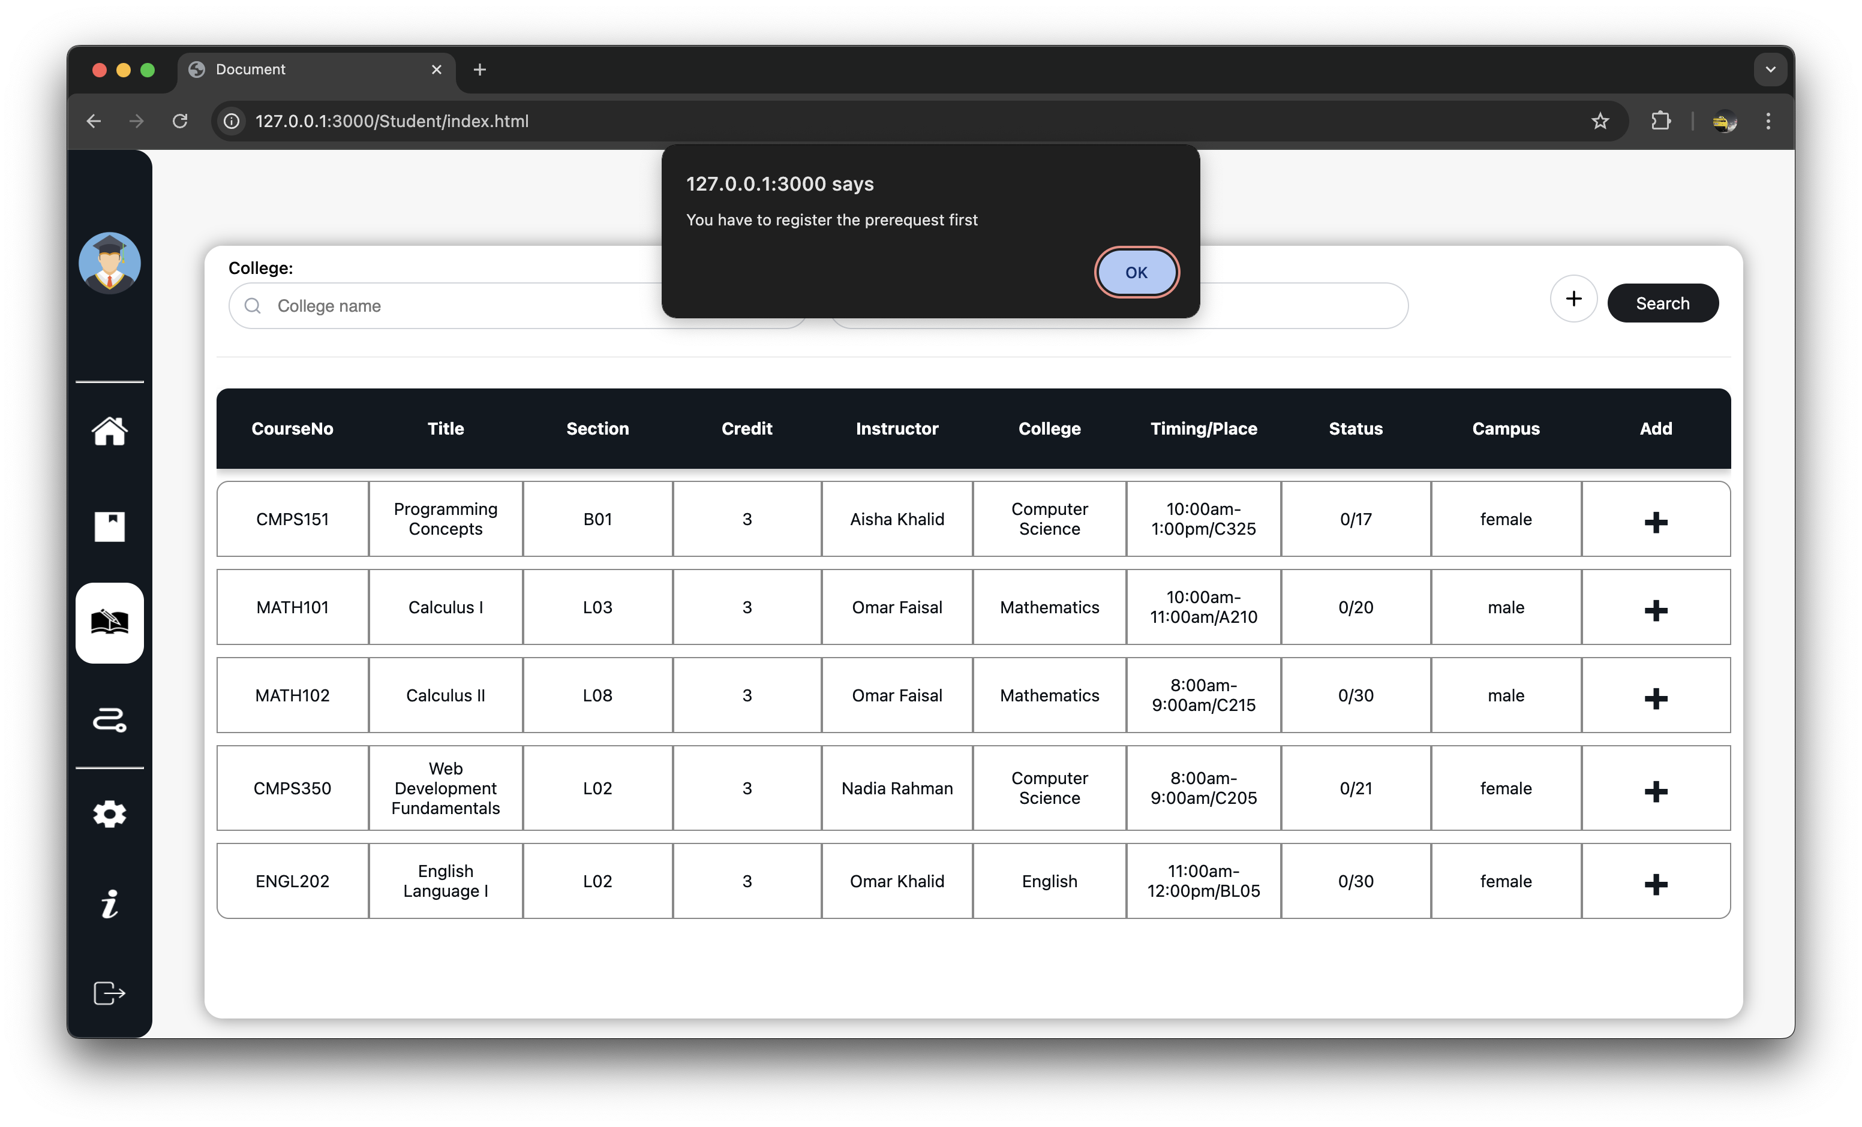

# Use case 4

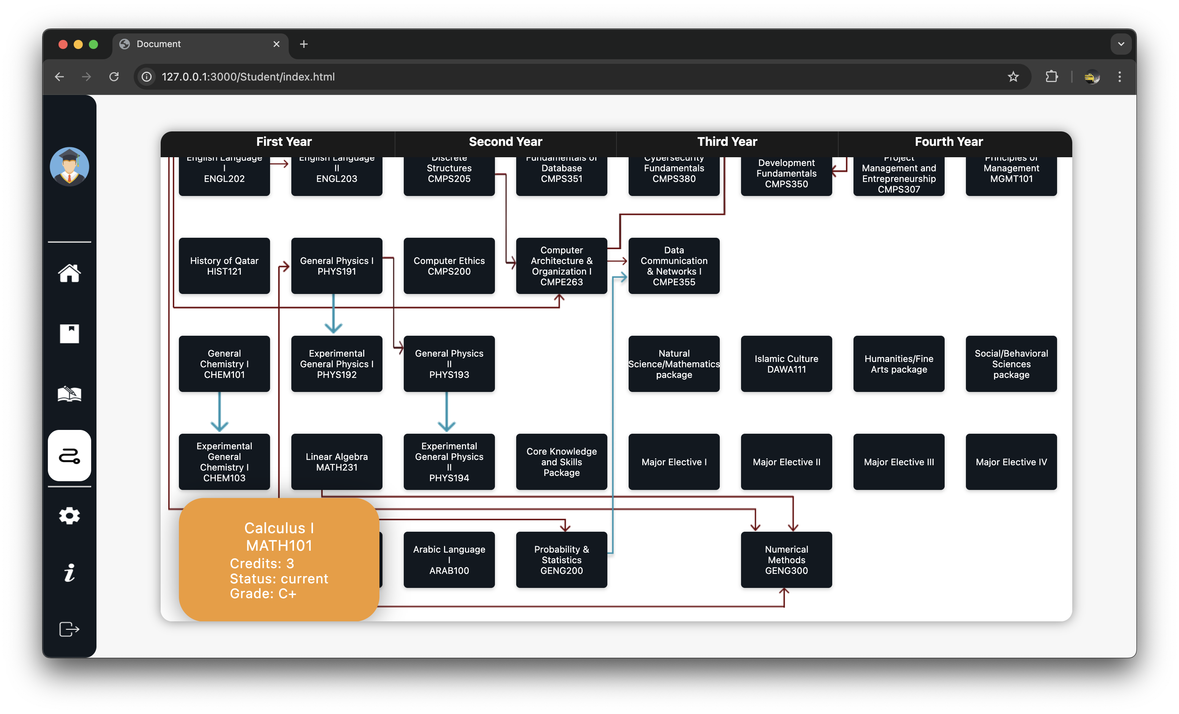

# Use case 5

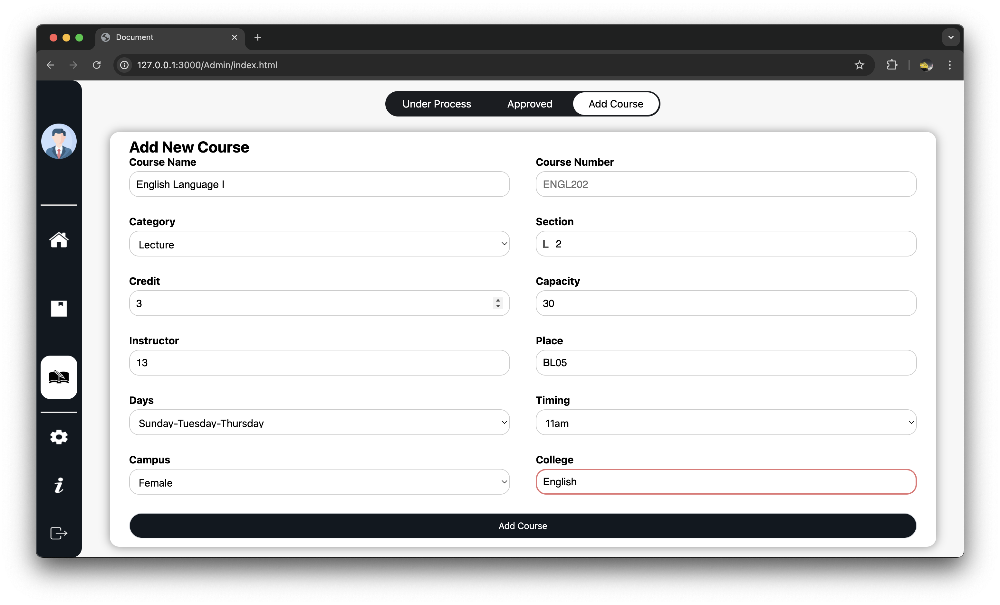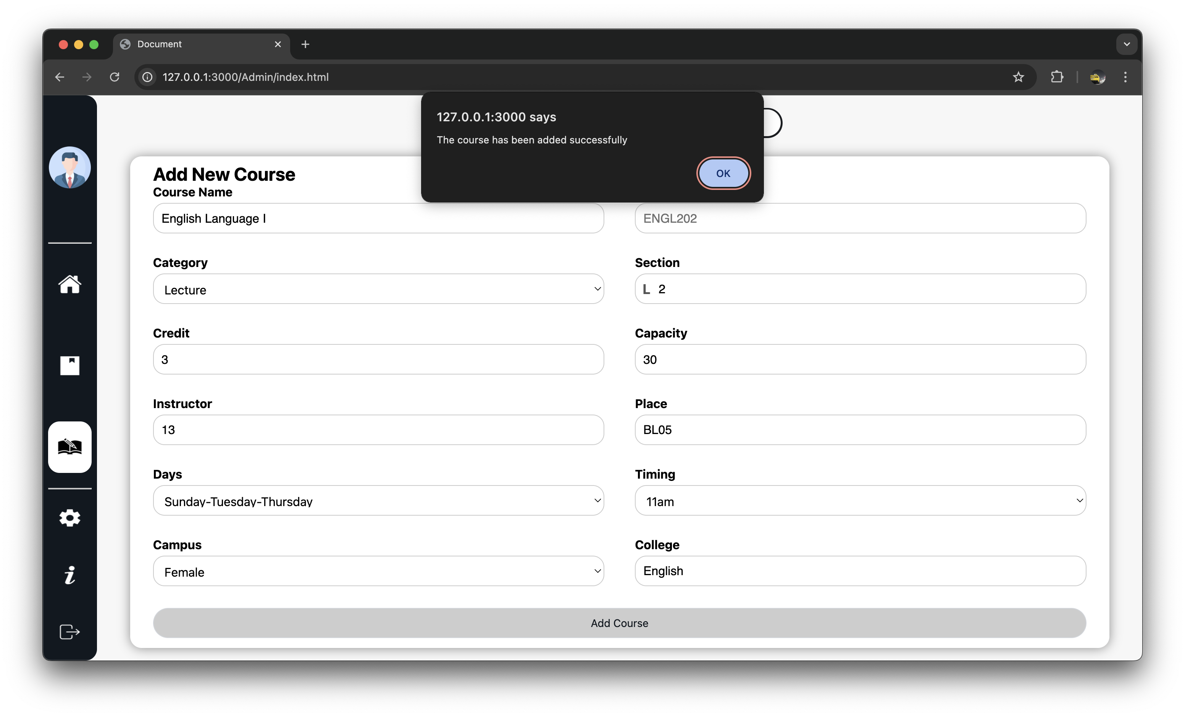 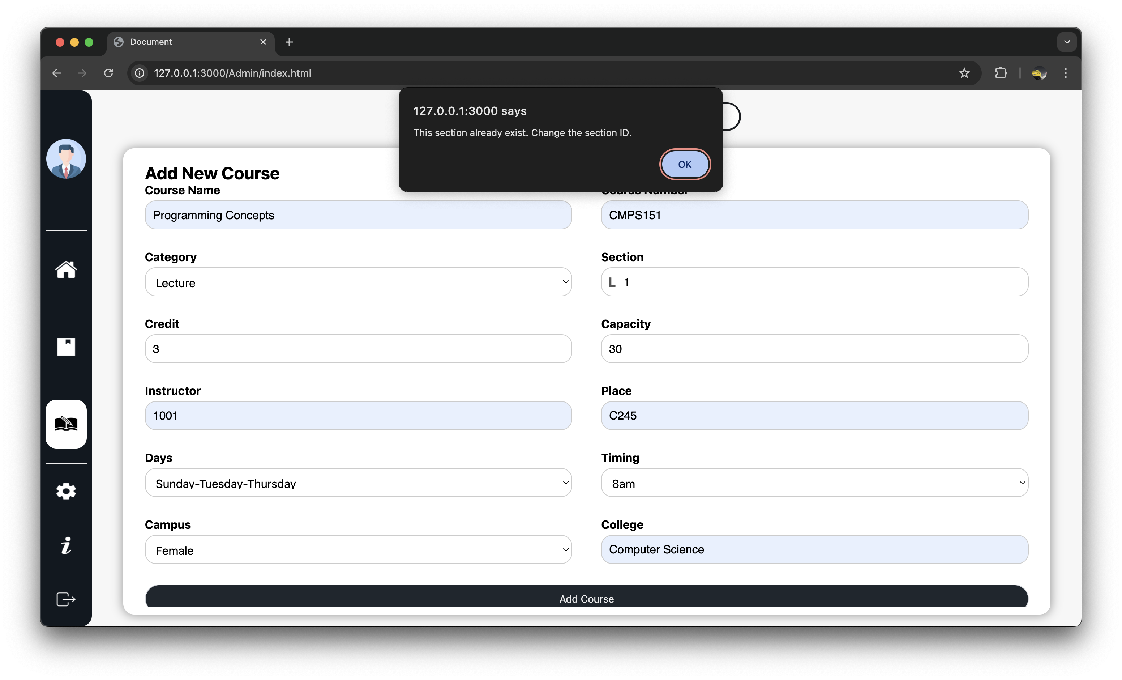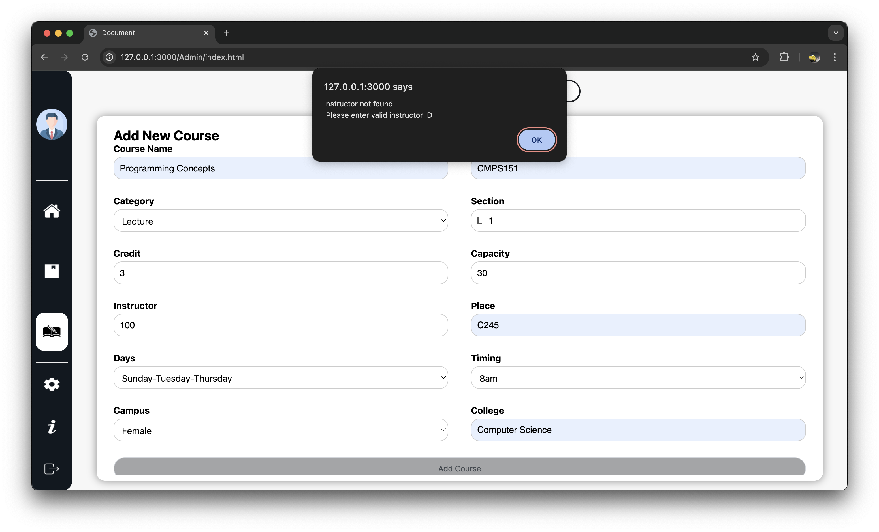

# Discussion of the project contribution of each team member

|  |  |
| --- | --- |
| **Student name** | **Student contributions** |
| Abdul Rahim Alsheikh Mahmoud | 33.33% |
| Abdalrehman Daud | 33.33% |
| Anas Elrahmani | 33.33% |
|  |  |
|  |  |

Assets:

